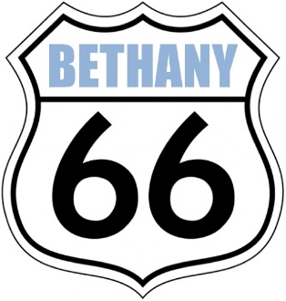
Car, Truck, and Bike Show
Trophies and Cash Prizes
Bethany 66 Festival
Asbury Street beneath murals
Route 66 in downtown Bethany
May 26, 2018
10 a.m. – 4:00 p.m.
(check in after 8 a.m.)

Return to Bethany Improvement Foundation c/o Marcia Doom, Treasurer
Bethany Bank & Trust 6500 NW 39th Expressway Bethany, OK 73008 mdoom@firstbethany.com

Today’s date___________Your name (print)____________________________

Vehicle Make______________Model_______________Year__________Class__________

Class entered (check one class only, separate entry for each vehicle)
____1. 1939 & Older Car
____2. 1939 & Older Truck
____3. 1940-1949 Car
____4. 1940-1949 Truck
____5. 1950- 1959 Car
____6. 1950- 1959 Truck
____7. 1960-1969 Car
____8. 1960-1969 Truck
____9. 1970-1979 Car
___10. 1970- 1979 Truck
___11. 1980- 1989 Car
___12. 1980- 1989 Truck
___13. 1990-- 1999 Car
___14. 1990 – 1999 Truck
___15. 2000-2009 Car
___16. 2000 -2009 Truck
___17. 2010 – Current Car
___18. 2010 – Current Truck
___19. Rat Rod
___20. Race Car

MOTORCYCLES:
____21. Custom Motorcycle
____22. Builders’ Class Motorcycle
____23. Street Bike
____24. Vintage Motorcycle
____25. Stock Motorcycle
____26. Scooter

______________(turn over for entry fee information)___________

Your name (printed)_________________________________________

Cell or home phone _________________________________________

E-mail_____________________________________________________

Mailing address_____________________________________________

_____________________________________________

Entry fee: $15 per vehicle before May 1 ($20 up to day of event)

Payment is included (ck. no.______) payable to the Bethany Improvement Foundation or charged to MasterCard or Visa #_________________________________________
Expires_________________ Security code from back of card____________________
Signature of cardholder___________________________________________________

BY YOUR SIGNATURE BELOW, YOU AGREE TO RELEASE AND DISCHARGE THE BETHANY IMPROVEMENT FOUNDATION AND CITY OF BETHANY, SPONSORS and anyone else connected with the management or presentation if this Car Show from any and all known and unknown damages, injuries, losses, judgments or claims from any cause whatsoever that may be suffered by the entrant to his/her property or person. You further agree to be responsible for any damage you may causes, intended or unintended to other registrants’ personal property and person, including their vehicles, caused by you or your property for any reason. Photos of vehicles may be used for promotion of the Bethany 66 Festival event.

You also agree to follow the rules of the show, which include: No music (music will be supplied by the festival), no alcoholic beverages during the show, and if using a tent, you will assure it is tied down so it cannot be blown into vehicles being shown or otherwise parked, including the property of others.

Signature___________________________ Printed name_______________________________

The Bethany Improvement Foundation is a 501c3 charitable organization.
For more details of the Bethany 66 Festival and BIF Projects, go to www.bethany66.ccom
Return to Bethany Improvement Foundation c/o Marcia Doom, Treasurer
Bethany Bank & Trust 6500 NW 39th Expressway Bethany, OK 73008 mdoom@firstbethany.com

